#### **1. TOP 10 CATEGORY B Sales**

* **Highlight Insight:**
  + "health_beauty accounted for 14.85% of TotalSales."
  + "Across all 10 product_category_name_, TotalSales ranged from 4,85,256.46 to 12,58,681.34."

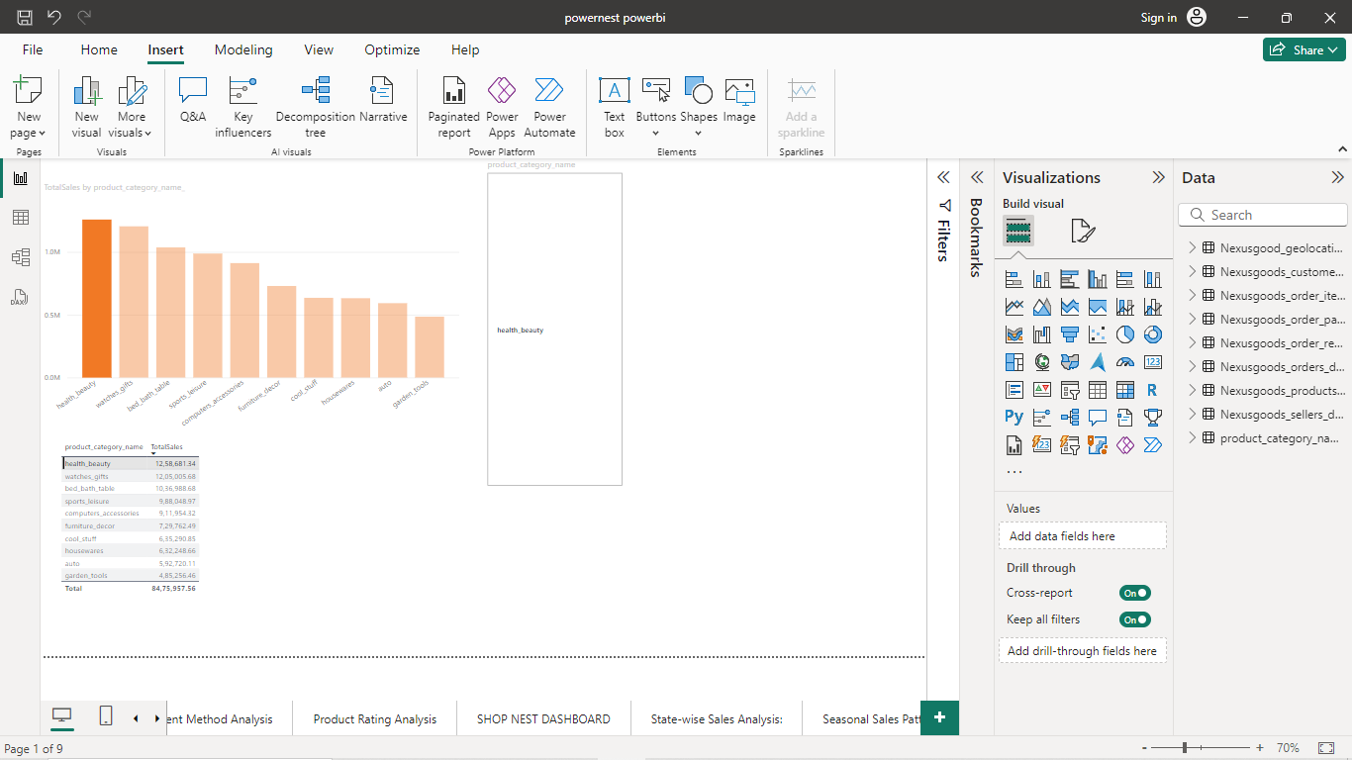

#### **2. Delayed Orders Analysis**

* **Highlight Insight:**
  + "IN, March had the highest DelayedOrders and was 694.62% higher than June, which had the lowest DelayedOrders at 223."

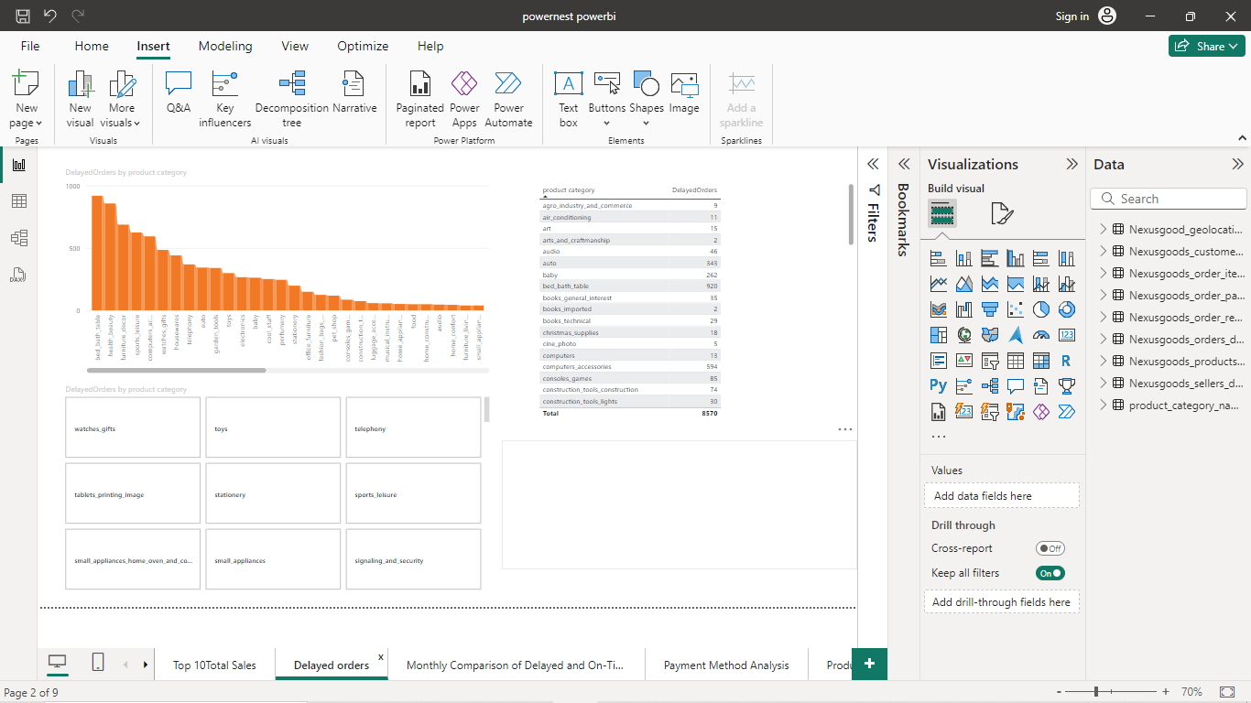

#### **3. Comparison of On-Time and Delayed Orders**

* **Highlight Insight:**
  + "OnTimeOrders and DelayedOrders diverged the most when the MonthName was July, when OnTimeOrders were 10568 higher than DelayedOrders."

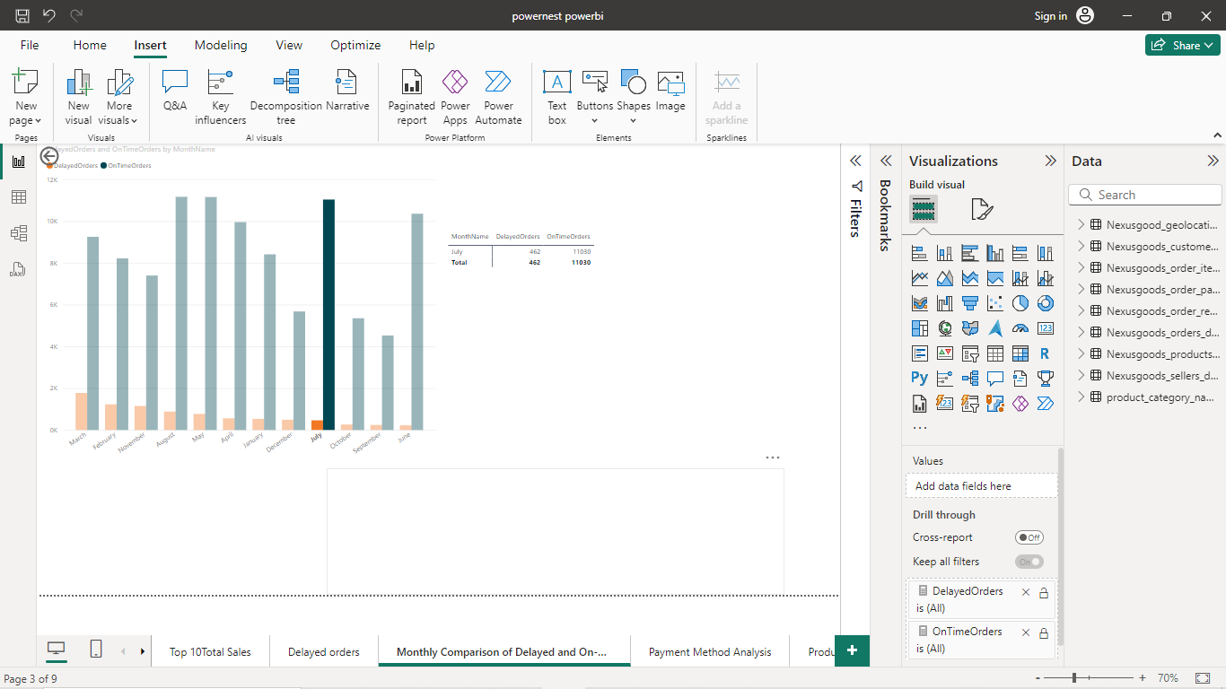

#### 

#### 

#### 

#### **4. Payment Method Analysis:**

#### 

**Highlight Insight: In payment method credit card has major share compare to other payment method**

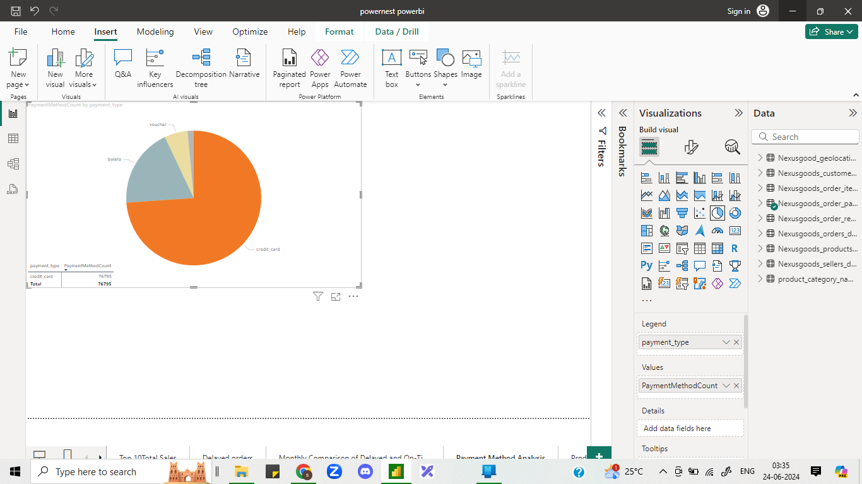

#### **5 Product Rating Analysis:**

#### **Highlight Insight .**

#### **In ratings analysis cds *dvds*_musicals has top rating**

* + Audio sales has in first from bottom 10 rating
  + 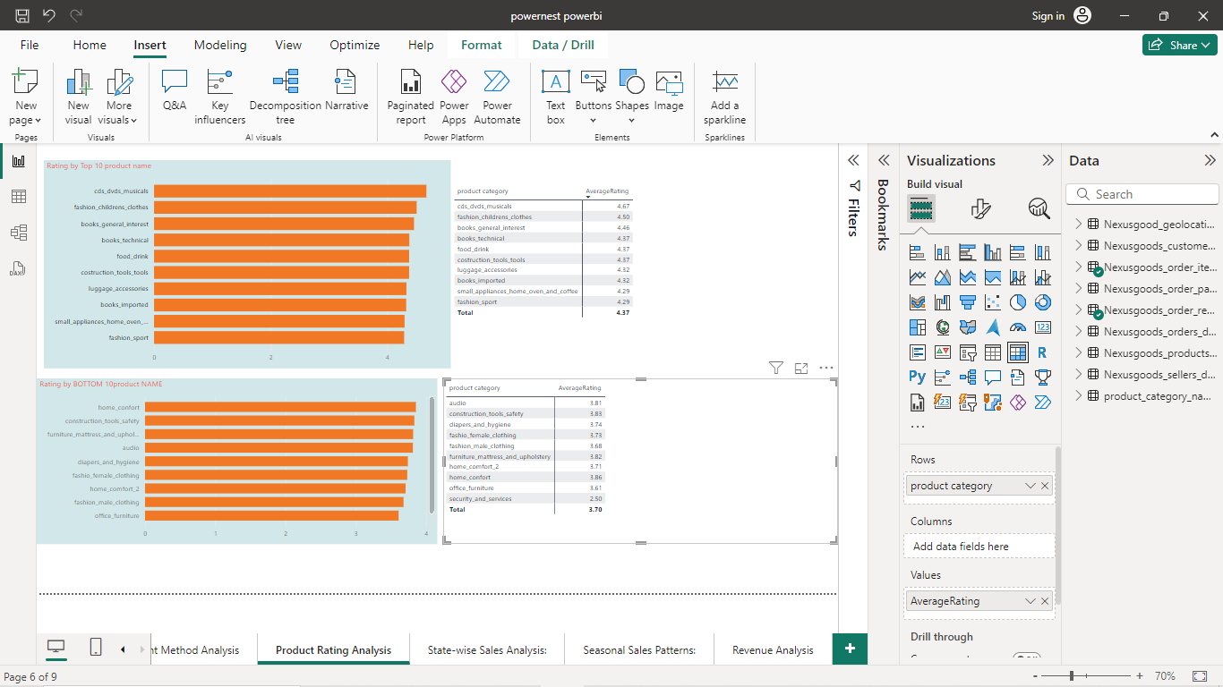

#### **6.State-wise Sales Analysis:**

#### **Highlight Insight**

#### **IN state wise sales south american state has more sales compare to other**

* + 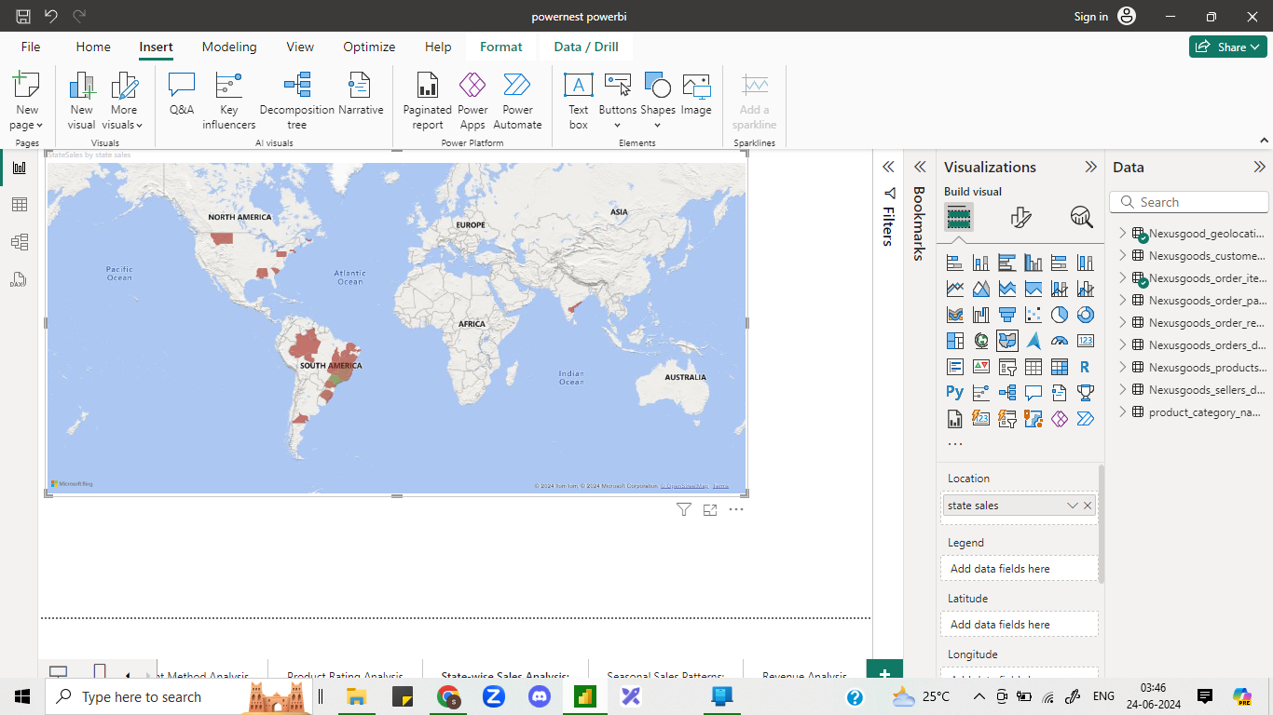

#### **7.Seasonal Sales Patterns:**

#### **Highlight Insight**

#### **IN seasonal sales quarter 2 has more sales compare to other**

#### **.**

#### 

#### 

#### 

#### 

#### 

#### 

#### 

#### 

#### 

#### 

#### 

#### **8 Revenue Analysis:**

#### **Highlight Insight**

#### **In 2018 year has more revenue compare to other year**

* + 

 